**Assignment-3 & 4**

**Yogitha Mekala**

**16354649**

**1.**

* **API used:** Sportspage Feeds
* It needs to be subscribed for a Basic plan which we can pull 20 per day.

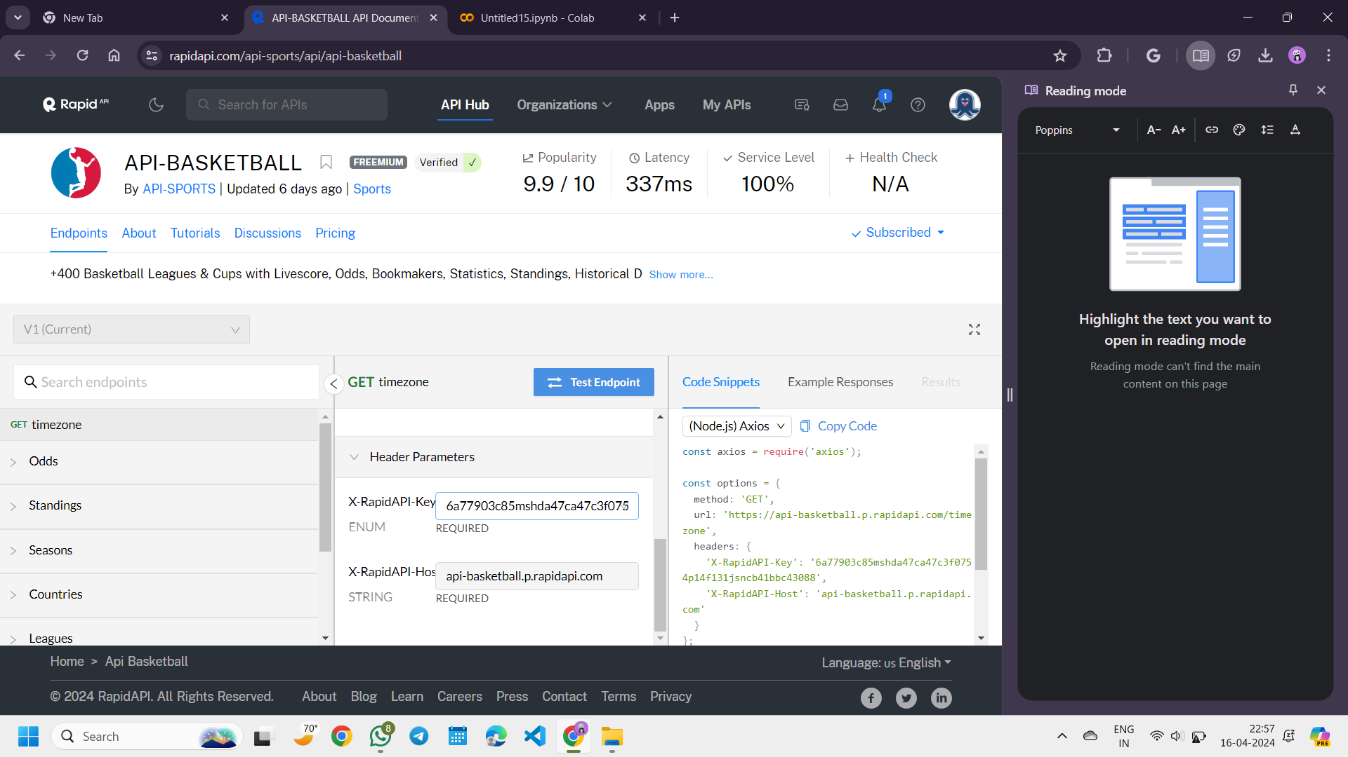

* We can run the requests code in our colab which generates the data of the API.

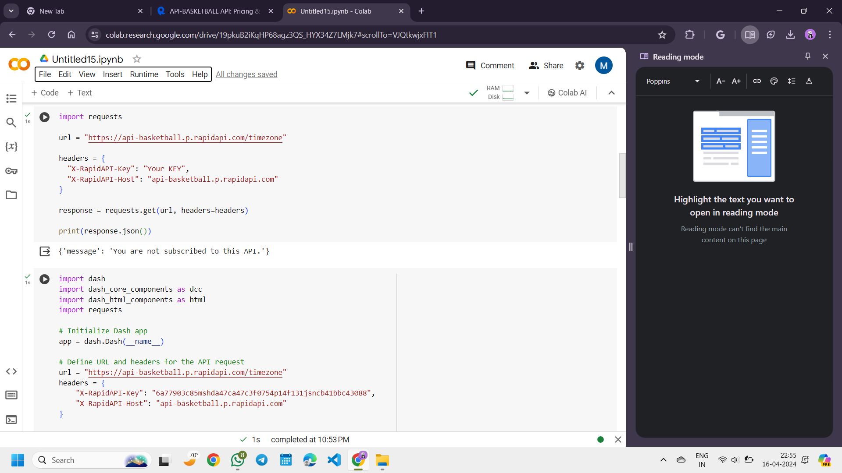



* **Generating data using dash**
* **Visualizations**

**There are two different visualizations:**

1. **AP Poll**

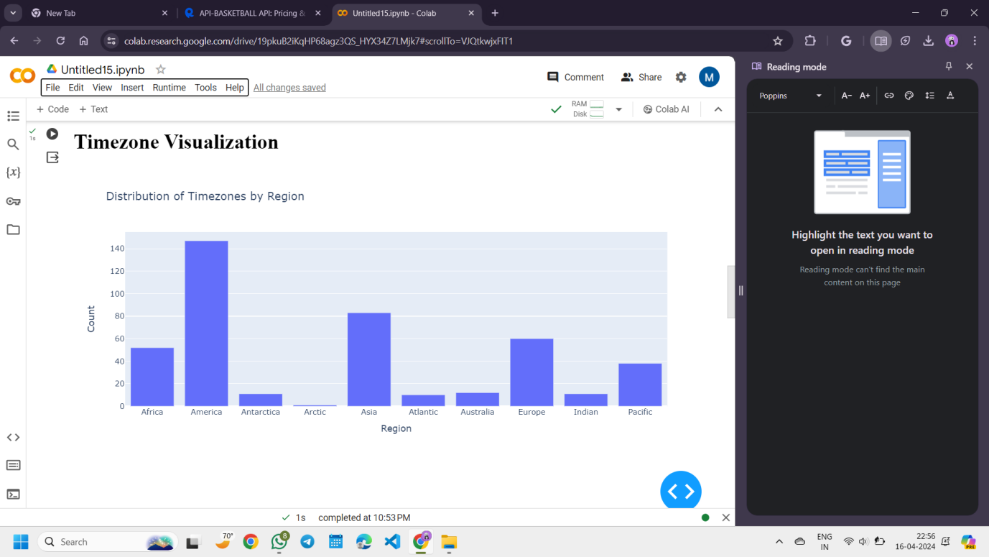

1. **Coaches Poll**

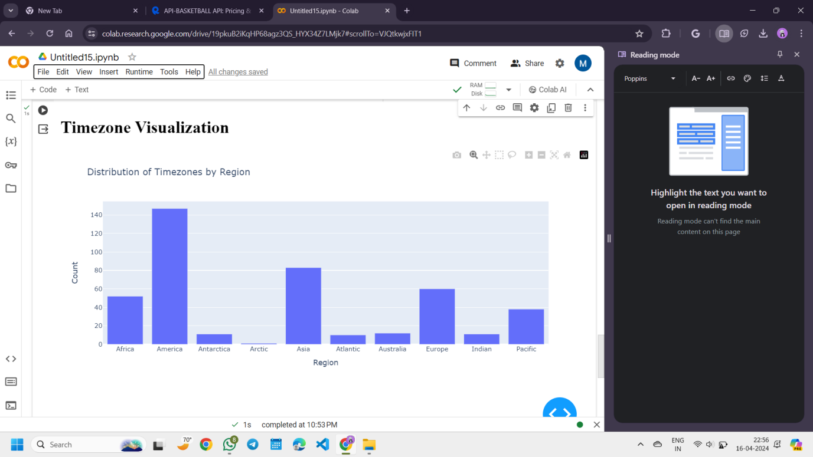

**2)** **The data file diabetes.csv contains data of 768 patients.**

**Data_Clean:**

**Given Dataset:**

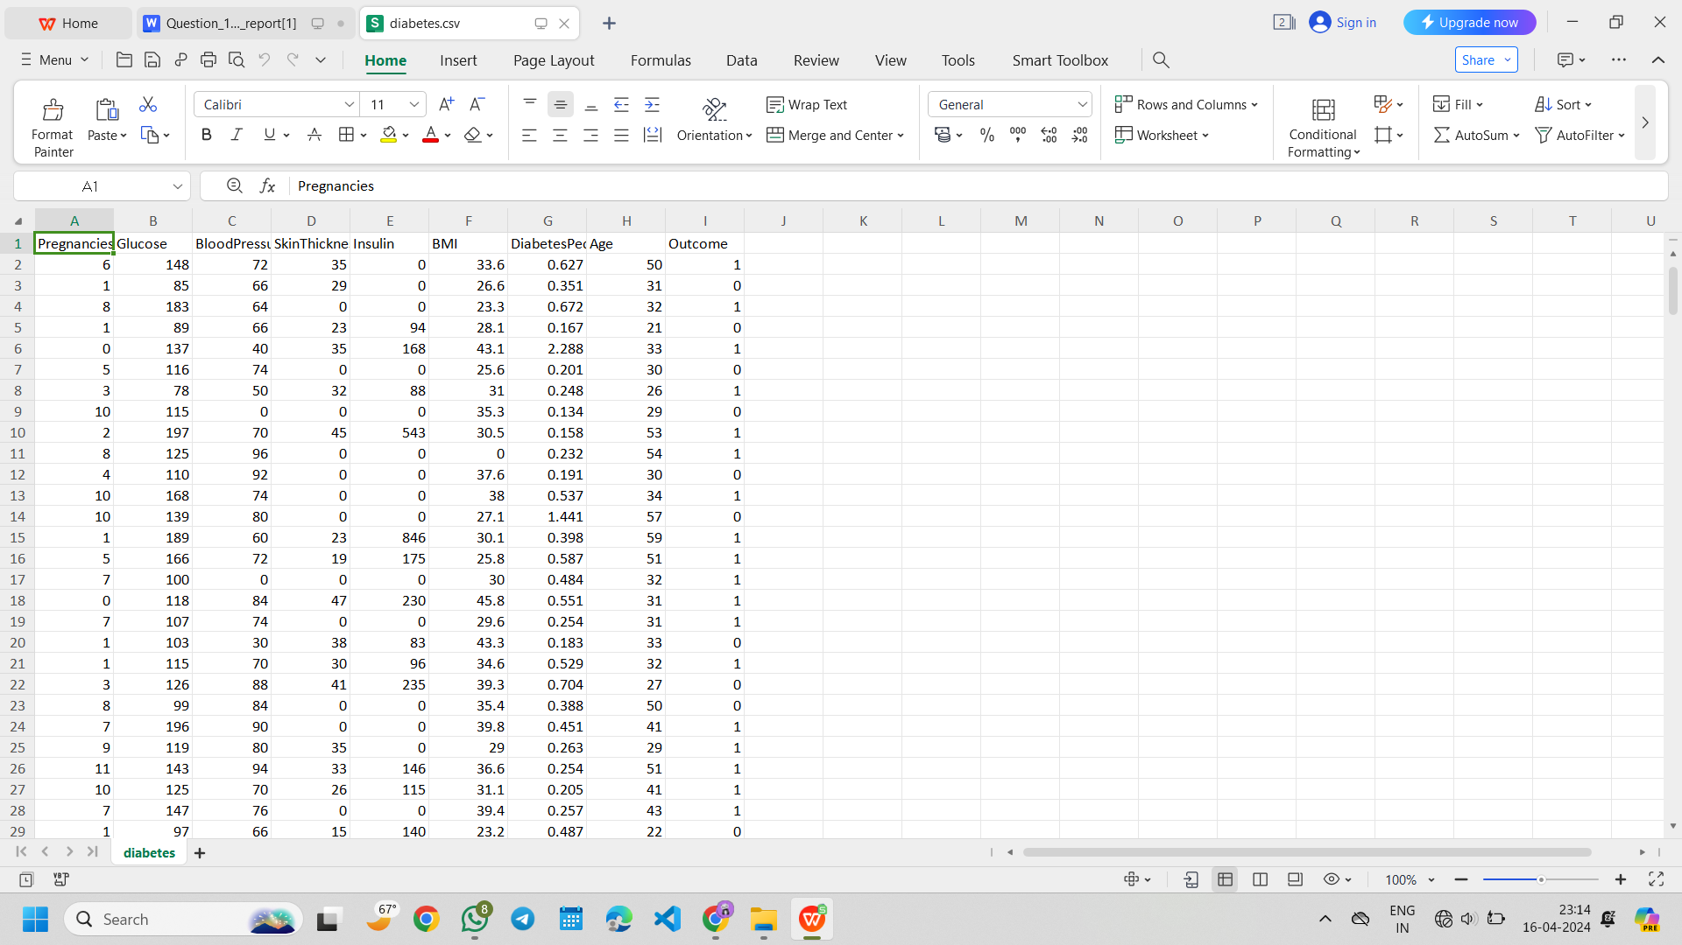

**In this data there are 8 attributes (Pregnancies, Glucose, BloodPressure, SkinThickness, Insulin, BMI, DiabetesPedigreeFunction, and Age) and 1 response variable (Outcome). The response variable, Outcome, has binary value (1 indicating the outcome is diabetes and 0 means no diabetes).**

**Checking for missing values:**

**Collecting the dataset information:**

**Data_Analysis**

1. **set a seed (to ensure work reproducibility) and take a random sample of 25 observations and find the mean Glucose and highest Glucose values of this sample and compare these statistics with the population statistics of the same variable.**

**np.random.seed() :** Setting a seed for reproducibility ensures that the random numbers generated by a computer program are the same every time the program is run. This is particularly useful when you're testing or debugging code, or when you want to ensure that others can replicate your results exactly. This means that every time you generate random numbers using NumPy functions after setting the seed to 42, you will get the same sequence of random numbers.

* **The below shows the Bar Chart and the Pie Chart for the comparison of the results.**

**Bar Chart**

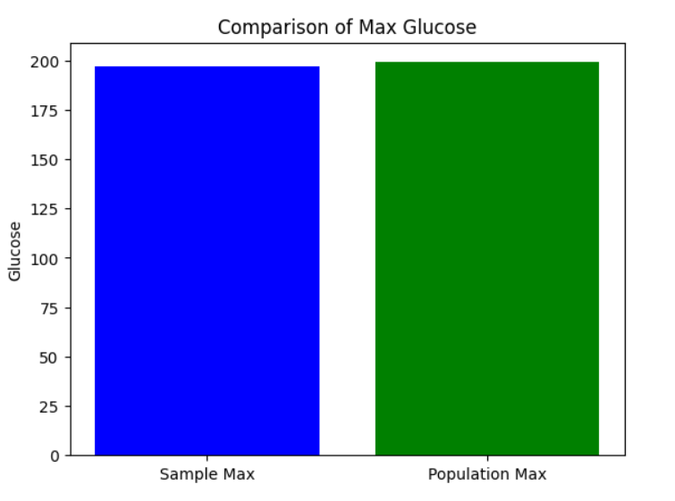

**Pie Chart**

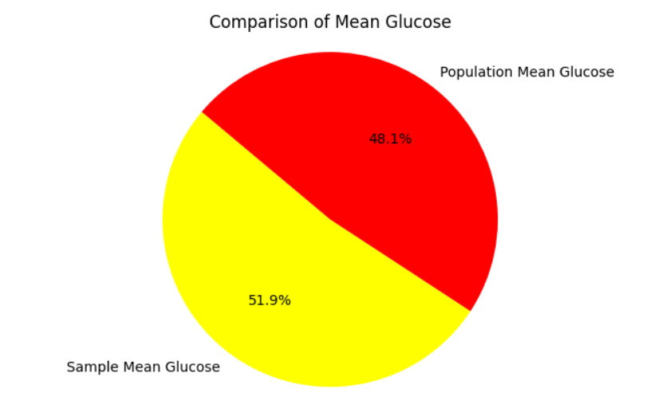

1. **Find the 98th percentile of BMI of your sample and the population and compare the results using charts.**

* **The below shows the Scatter Plot and Histogram for the 98th percentile of BMI of the sample and the population.**

**Scatter Plot**

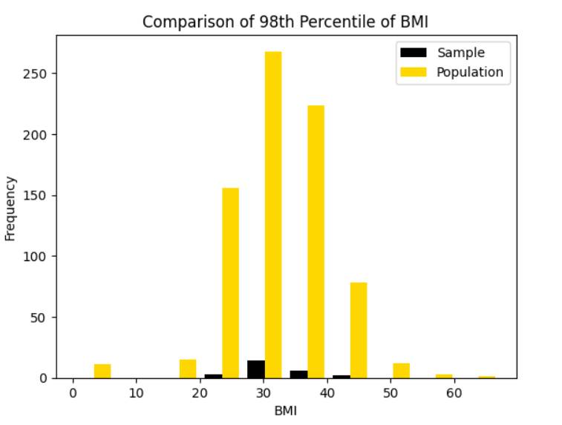

**Histogram**

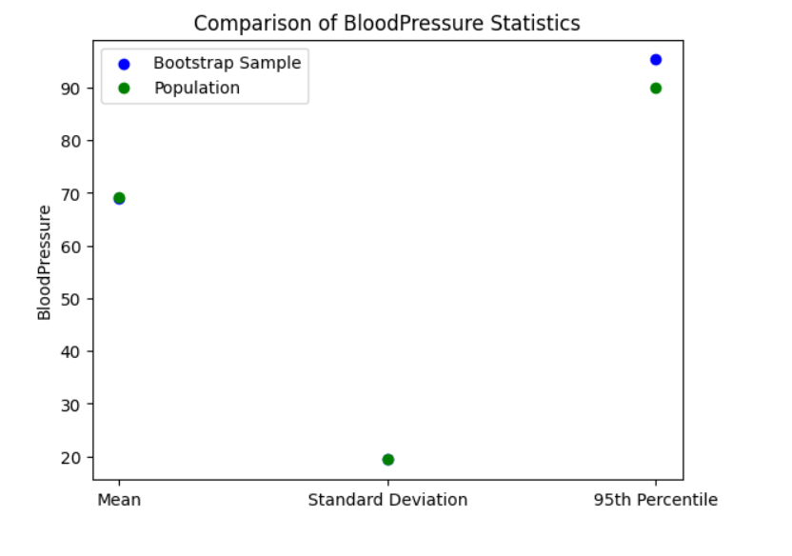

**c. Using bootstrap (replace= True), create 500 samples (of 150 observation each) from the**

**population and find the average mean, standard deviation and percentile for BloodPressure and compare this with these statistics from the population for the same variable. Again, you should create charts for this comparison. Report on your findings.**

